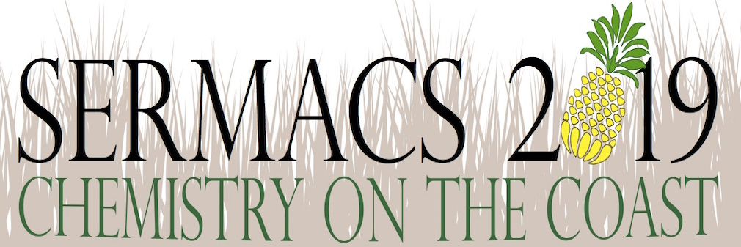
Sponsor Benefits

Diamond ‐ $10,000+
Benefits include:
- Program App advertisement (premium time and duration)
- Five (5) attendee passes
- Website logo and link
- Exposition booth

Graphite ‐ $5,000 ‐ $9,999
Benefits include:
- Program App advertisement (superior time and duration)
- Three (3) attendee passes
- Website logo and link

Benzene ‐ $2,500 ‐ $4,999
Benefits include:
- Program App advertisement
- Two (2) attendee passes
- Website logo and link

Ethylene ‐ $1,000 ‐ $2,499
Benefits include:
- One (1) attendee pass
- Website logo and link

Ethanol ‐ $500 ‐ $999
Benefits include:
- Website logo and link

Methane ‐ <$500
Benefits include:
- Recognition on Sponsor signage

For more info: sermacs2019@gmail.com

